 | Autumn 1 | Autumn 2 | Spring 1 | Spring 2 | Summer 1 | Summer 2
Nursery | Foxes favourite autumn  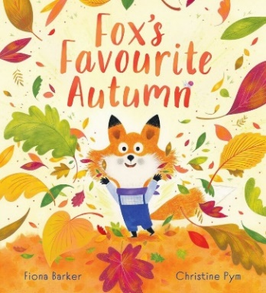 | 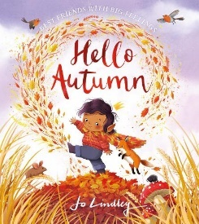  Hello Autumn  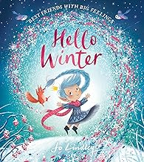  Hello Winter | Maisy’s Chinese New Year  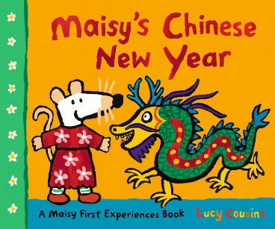 | 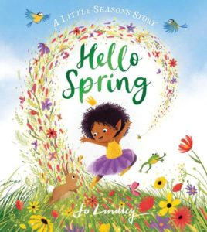  Hello Spring | 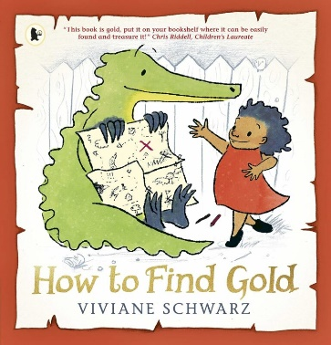  How to find gold | 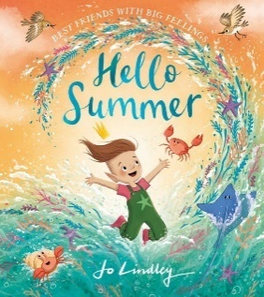  Hello Summer

 | Autumn 1 | Autumn 2 | Spring 1 | Spring 2 | Summer 1 | Summer 2
Reception | Big Picture Atlas  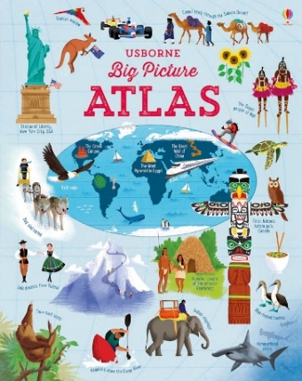 | Goodbye Autumn, Hello Winter  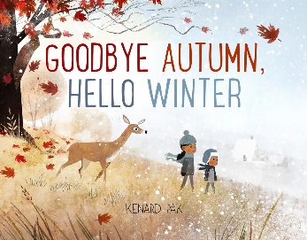 | Coming to England  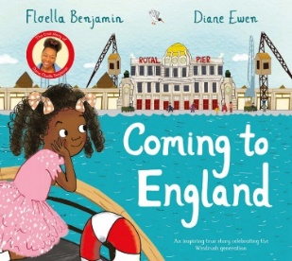 | That’s my Flower  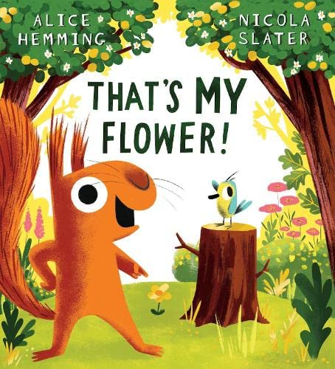 | First Atlas  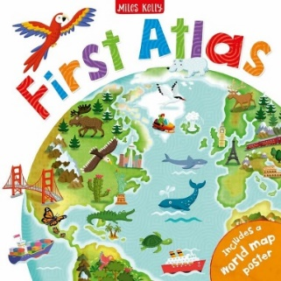  What the Ladybird Heard at the Seaside  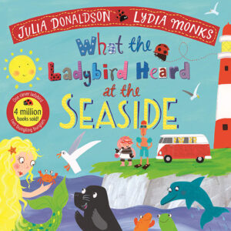 | 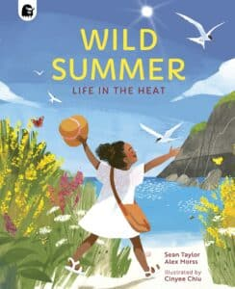  Wild Summer

 | Autumn 1 | Autumn 2 | Spring 1 | Spring 2 | Summer 1 | Summer 2
KS1 Cycle A |  | Ollie’s Back-to-School Bear  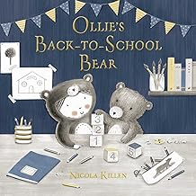 |  | Katie in London  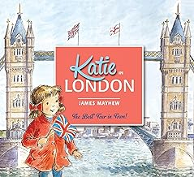  Paddington’s London Treasury  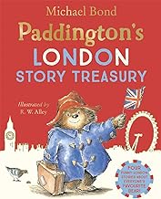  The Big Book of the UK  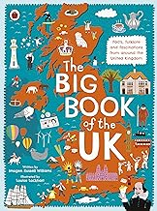 |  | Maybe you Might  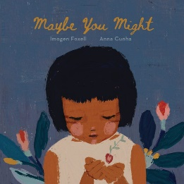

 | Autumn 1 | Autumn 2 | Spring 1 | Spring 2 | Summer 1 | Summer 2
KS1 Cycle B |  | Wild Weather  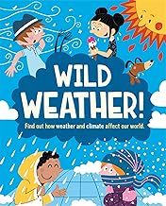 |  | The Storm Whale  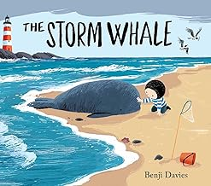  Billy’s Bucket  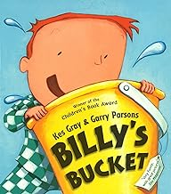 |  | Martha Maps it Out  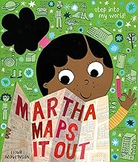

 | Autumn 1 | Autumn 2 | Spring 1 | Spring 2 | Summer 1 | Summer 2
LKS2 Cycle A |  | The Big Book of the UK  Coming to England  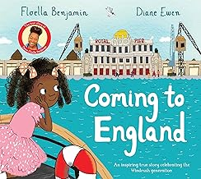 |  | Rainforest Warrior  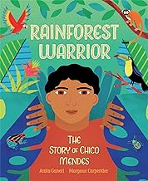  My Name is River  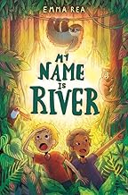 |  | Here We Are  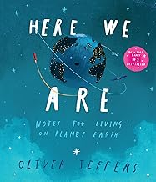  Dear Earth  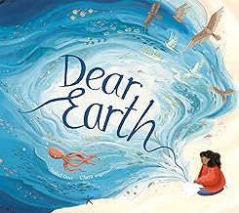

 | Autumn 1 | Autumn 2 | Spring 1 | Spring 2 | Summer 1 | Summer 2
LKS2 Cycle B |  | Song of the Dolphin Boy  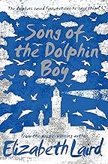  Why Water’s Worth It  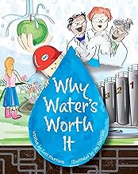 |  | Where Does My Food Come From?  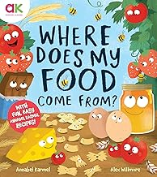 |  | Investigasting Village Settlements  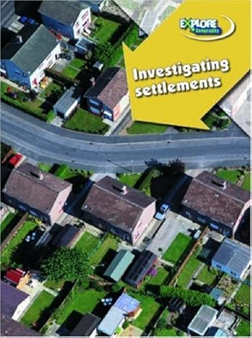

 | Autumn 1 | Autumn 2 | Spring 1 | Spring 2 | Summer 1 | Summer 2
UKS1 Cycle A |  | Secret of the Glass Mountain and Other Folktales from Ukraine  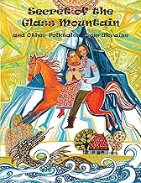 |  | Planet Power: Explore the World’s Renewable Energy  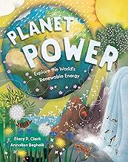 |  | Your Passport to El Salvador  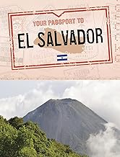
UKS2 Cycle B |  | Old Enough to Save the Planet  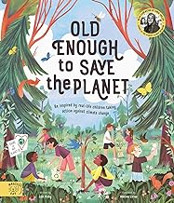 |  | Kidnap on the California Comet  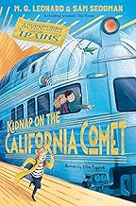 |  | Noah’s Gold  